

**BACK TO OFFICE REPORT**

**2024 United Nations Biodiversity Conference**

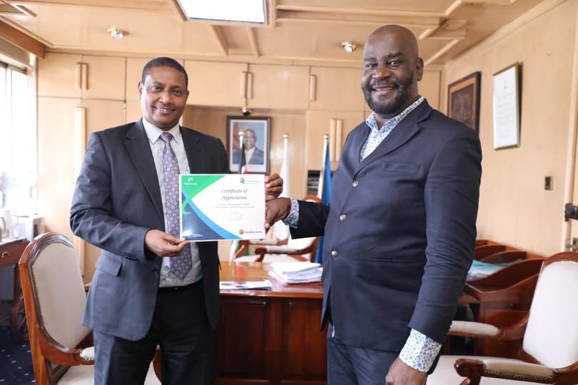

**Joseph Masinde (CHM Desk) presents the Clearing House Mechanism (CHM) Award Certificate of Recognition to the Director General NEMA**

**Kenya's recognition with a Certificate of Recognition underscores its dedication to promoting biodiversity data-sharing via its national CHM designated at NEMA**

**THE 5th MEETING OF THE SUBSIDIARY BODY ON IMPLEMENTATION (SBI 5) TO HELD ON 16TH TO 18TH OCTBOER, 2024; 11th MEETING OF THE CONFERENCE OF THE PARTIES SERVING AS THE MEETING OF THE PARTIES TO THE CARTAGENA PROTOCOL ON BIOSAFETY, 5th MEETING OF THE CONFERENCE OF THE PARTIES SERVING AS THE MEETING OF THE PARTIES TO THE NAGOYA PROTOCOL ON ACCESS TO GENETIC RESOURCES AND THE FAIR AND EQUITABLE SHARING OF BENEFITS ARISING FROM THEIR UTILIZATION, 16th MEETING OF THE CONFERENCE OF THE PARTIES TO THE CONVENTION ON BIOLOGICAL DIVERSITY CONFERENCE OF PARTIES (COP16)**

**16TH OCTOBER TO 1ST NOVEMBER 2024,**

**CALI, COLOMBIA**

**By Joseph Masinde**

**Senior Environmental Education Information Officer**

**National CHM Desk**

**National Environment Management Authority**

 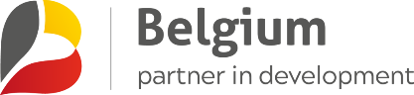

Contents

Introduction and Acknowledgment 3

**Substantive Agenda Items for COP16** 4

**Item 10 :Mechanisms for planning, monitoring, reporting and review** 4

Item 12 : Capacity-building and development, technical and scientific cooperation, clearing-house mechanism and knowledge management 5

Item 15 : Communications, education and public awareness 6

Item 17: Mainstreaming of biodiversity within and across sectors 7

Item 18 :Diverse values of biodiversity: 8

Conference of the Parties to the Convention on Biological Diversity serving as the meeting of the Parties to the Nagoya Protocol on Access to Genetic Resources and the Fair and Equitable Sharing of Benefits Arising from their Utilization Fifth meeting 9

Item 8 :Capacity-building and development and awareness-raising 9

Item 9 :Access and Benefit-sharing Clearing-House and information-sharing 10

**SIDE EVENTS** 11

National Clearing House Mechanism and Bioland 2.0 11

Access and Benefit-Sharing Clearing-House Training Workshop 13

Outcomes Relevant to Kenya’s Interests 15

Kenya Honoured at Global conference -COP16 for Outstanding National Clearing-House Mechanism on Biodiversity 16

# Introduction and Acknowledgment

This report provides a summary of my participation in the Sixteenth Meeting of the Conference of the Parties to the Convention on Biological Diversity (COP16), held in Cali, Colombia, from 20th October to 1st November 2024. As a representative of the National Environment Management Authority (NEMA), Kenya, and the National CHM desk officer, I actively engaged in discussions and sessions covering key agenda items, including planning, monitoring, reporting, capacity building, knowledge management, and mainstreaming biodiversity across sectors.

The side events I attended, including the National Clearing House Mechanism and Bioland 2.0 session and the Access and Benefit-Sharing Clearing-House Training Workshop, provided valuable insights into advancing knowledge-sharing platforms and strengthening the implementation of access and benefit-sharing mechanisms.

Kenya was awarded a Certificate of Appreciation on October 31, 2024, during COP16 of the Convention on Biological Diversity in Cali, Colombia. Presented by **CBD Executive Secretary Ms.Astrid Shomaker**, the award celebrates Kenyas well-organized National Clearing-House Mechanism (CHM) an online platform for managing and sharing biodiversity data, supporting the implementation Kunming -Montreal Global Biodiversity Framework

I extend my heartfelt gratitude to the Royal Belgian Institute of Natural Sciences (RBINS) for their generous support (Travel and Accommodation) through the CHM Partnership and the CEBioS program. Their commitment to building capacity and supporting partner countries in managing and enhancing their Clearing-House Mechanisms was instrumental in facilitating my participation. This support not only enhanced my understanding of CHM-related processes but also bolstered Kenya's efforts in aligning with the Kunming-Montreal Global Biodiversity Framework goals.

This report aims to share key outcomes and lessons learned from COP16 to inform and strengthen Kenya’s biodiversity initiatives and CHM activities.

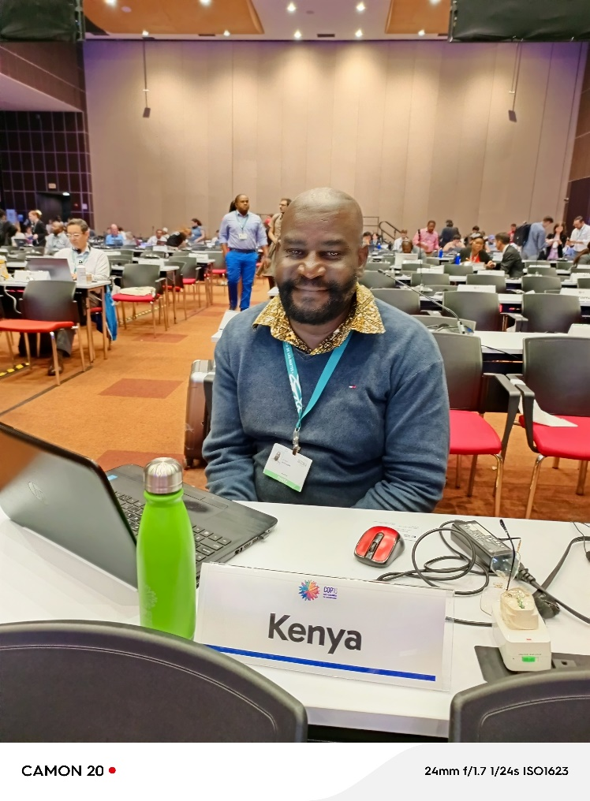

**Myself at the Kenyan desk.**

# **Substantive Agenda Items for COP16**

## **Item 10 :Mechanisms for planning, monitoring, reporting and review**

The Kunming-Montreal Global Biodiversity Framework is supported by a monitoring framework and an enhanced multidimensional approach to planning, monitoring, reporting and review, adopted in decisions 15/5 and 15/6, respectively.

Also in its decision 15/5, the Conference of the Parties established the Ad Hoc Technical Expert Group on Indicators to advice on the further operationalization of the monitoring framework for the Kunming-Montreal Global Biodiversity Framework.

On Monday, 21 October, Working Group I initiated discussions on the Global Biodiversity Framework (GBF) monitoring framework and mechanisms for planning, monitoring, reporting, and review (PMRR), establishing a contact group to address unresolved matters, co-chaired by Gillian Guthrie (Jamaica) and Carolina Caceres (Canada). Co-facilitated by Ntakadzeni Tshidada (South Africa) and Anne Teller (EU), the group met on multiple days to discuss procedures, content, and information sources for the global review, alongside guidance on GBF indicators.

**Outcomes**

On Wednesday, 30 October, Working Group I approved most elements of the draft monitoring decision, requesting the Global Environment Facility (GEF) to provide financial resources for national biodiversity monitoring systems and supporting community-based monitoring. While most annexes were accepted with minor amendments, unresolved brackets remained on certain indicators related to pesticides and sustainable consumption. The draft decision was ultimately bracketed due to the Democratic Republic of the Congo’s intervention, emphasizing the need for the PMRR, resource mobilization, and financial mechanisms to be adopted as a comprehensive package.

**Interventions by Kenya’s delegation**

Supporting the DRC’s position, Kenya advocated for a holistic approach in adopting mechanisms for PMRR, resource mobilization, and finance

**Recommendations**

Further strengthening its national biodiversity monitoring systems by seeking financial and technical support from the Global Environment Facility (GEF). This could ensure robust tracking of biodiversity targets and progress toward the GBF goals.

Emphasizing the importance of community engagement, Kenya propose the development and support of community-based monitoring and information systems. This aligns with the encouragement for community involvement in decision 15/5, which would improve local data collection, increase accountability, and enhance awareness at the grassroots level.

## Item 12 : Capacity-building and development, technical and scientific cooperation, clearing-house mechanism and knowledge management

On 22 October, Working Group I (WG I) began discussions on two draft decisions concerning **capacity-building and development, technical and scientific cooperation (TSC),** the **Clearing-House Mechanism (CHM), and knowledge management**. A contact group, co-chaired by Mukondi Matshusa (South Africa) and Holly Kelley-Weil (UK), was established and met on 22, 23, and 28 October to address revisions. Delegates reviewed updated drafts on 31 October, agreeing to adjust language on financial support from the Global Environment Facility (GEF) for capacity-building in all eligible countries and removing references to a second call for regional support centers. The decision on CHM maintained data sovereignty provisions while deleting references to specific groups, emphasizing support for country-driven projects and the inclusion of all eligible parties.

**Outcome**

In the final decisions, the COP adopted strategies on capacity-building and TSC, with provisions for monitoring progress alongside the Global Biodiversity Framework (GBF). The COP mandated the Informal Advisory Group to assess and address technological and institutional capacity gaps, with an independent evaluation scheduled for 2029. For the CHM, the COP adopted a 2024-2030 work program, encouraging parties to nominate national CHM focal points and to contribute financial resources for capacity-building activities. The COP also agreed on a knowledge management strategy supporting GBF implementation, with the Secretariat tasked with collaborating on global standards and vocabularies to enhance biodiversity knowledge sharing.

The decision contains two annexes: on the programme of work for the CHM for the period 2024-2030, and on the knowledge management strategy to support the implementation of the GBF.

**Recommendations**

Kenya emphasize continued engagement with the Global Environment Facility (GEF) to secure financial support for capacity-building projects that align with National Strategy Biodiversity Action Plan.

Kenya encourage the identification and addressing of technological and institutional capability gaps, in line with COP mandates, to build a robust foundation for biodiversity monitoring and implementation.

Promote National CHM Focal Points and Knowledge Management: By Strengthening the national focal point for the Clearing-House Mechanism (CHM) at NEMA by putting in place mechanisms to collect data and information from stakeholders.

Kenya facilitate data sovereignty, ensure relevant national and local data sharing, and enhance knowledge exchange. Participation in the 2024-2030 CHM program and knowledge management strategy can improve Kenya's biodiversity data management and international reporting.

Foster a knowledge-sharing culture that supports GBF implementation.

## Item 15 : Communications, education and public awareness

On 1 November, the Conference of the Parties (COP) finalized discussions on the Communication, Education, and Public Awareness (CEPA) program. Working Group I (WG I) agreed to align CEPA’s program of work with the Global Biodiversity Framework (GBF), emphasizing the need for adequate resources to support developing countries in implementing the GBF and CEPA actions. Delegates endorsed “transformative actions” to implement the GBF rather than the broader concept of “transformative change.”

**Outcome**

In the final decision (CBD/COP/16/L.29), the COP established a flexible, voluntary framework encouraging parties to implement national actions aligning CEPA with the GBF. UNESCO, IPBES, and the Global Youth Biodiversity Network (GYBN) were invited to collaborate on developing a global biodiversity education plan. The COP urged parties and stakeholders to contribute resources to CEPA, while the Secretariat was tasked with collaborating on a global action plan, aligning the CEPA work program with the GBF, and submitting a progress report by COP 17.

**Recommendations**

Kenya prioritize securing resources for CEPA initiatives, specifically targeting actions that align with the GBF. This could involve leveraging international funding and partnerships to support communication, education, and awareness programs at both national and community levels.

Kenya consider developing educational programs aligned with the GBF, working closely with schools, community groups, and local governments to foster biodiversity awareness. This could be supported by engaging with UNESCO and other global bodies involved in biodiversity education.

Strengthen Community and Youth Engagement through collaboration with organizations like GYBN, Kenya can create platforms for youth involvement in biodiversity conservation and awareness. Building on existing networks, Kenya can also foster community-led initiatives to drive transformative actions in line with the GBF.

Kenya should focus on promoting clear, accessible information on biodiversity conservation through various media to ensure widespread awareness and active public involvement in biodiversity protection efforts.

## Item 17: Mainstreaming of biodiversity within and across sectors

**Mainstreaming:** The Conference of the Parties (COP) urged parties to integrate biodiversity mainstreaming into various sectors as part of the Global Biodiversity Framework (GBF). It emphasized engaging the private sector in biodiversity efforts and called on the Secretariat to:

Embed biodiversity mainstreaming in regional and subregional dialogues,

Collaborate with other conventions to enhance mainstreaming,

Support capacity-building on mainstreaming activities, and

Develop a sector-specific overview and communities of practice for COP 17.

## Item 18 :Diverse values of biodiversity:

The COP encouraged the integration of diverse values and knowledge systems into biodiversity policies, based on the IPBES report on nature's diverse values. The decision advocated:

Recognizing different perspectives on biodiversity in decision-making,

Involving Indigenous Peoples and Local Communities (IPLCs) in these processes,

Supporting participatory approaches to sustainability, and Considering diverse value systems when implementing GBF Target 14, which calls for incorporating biodiversity into decision-making.

**Recommendations**

Kenya should further integrate biodiversity considerations into policies for agriculture, forestry, infrastructure, tourism, and other key sectors. Developing cross-sectoral guidelines and standards could help align these efforts with the GBF and ensure all sectors contribute to national biodiversity goals.

Encouraging private sector contributions to biodiversity targets can boost Kenya’s biodiversity conservation efforts.

Kenya consider introducing incentives, like tax benefits or subsidies, to companies adopting biodiversity-friendly practices. Additionally, creating partnerships with businesses to fund and promote biodiversity initiatives could strengthen Kenya’s approach.

Kenya benefit from developing training programs to incorporate different value systems, including indigenous knowledge, in biodiversity policies. Capacity-building workshops with stakeholders across sectors would enhance understanding and application of these diverse values in national and local policies.

Since Kenya has rich Indigenous and local knowledge systems, creating platforms for IPLC participation in decision-making would ensure diverse values are reflected in policies. This involvement aligns with GBF Target 14 and promotes inclusive, sustainable management of biodiversity.

Kenya could initiate projects to assess the economic, social, and cultural values of biodiversity, ensuring these values are integrated into policy decisions. This holistic approach would support more comprehensive assessments and align Kenya’s biodiversity policies with GBF objectives.

# Conference of the Parties to the Convention on Biological Diversity serving as the meeting of the Parties to the Nagoya Protocol on Access to Genetic Resources and the Fair and Equitable Sharing of Benefits Arising from their Utilization Fifth meeting

## Item 8 :Capacity-building and development and awareness-raising

Capacity Building and Development, and Awareness Raising: On Monday, 21 October, Chair Benítez informed WG II that a CRP will be prepared, which was addressed on Thursday, 24 October. Discussion focused on the action plan annexed to the decision, including its outputs and capacity-building activities under thematic key areas. WG II approved the CRP as amended.

Final Outcome: The decision (CBD/NP/MOP/5/L.4) was not adopted due to the meeting’s suspension.

**Recommendations**

Given that the formal decision was not adopted, Kenya could still proceed with its own initiatives aligned with the action plan discussed. This could include developing targeted training programs for capacity-building in key areas relevant to the Nagoya Protocol, such as biodiversity conservation, sustainable use of resources, and benefit-sharing.

Kenya should identify priority thematic areas where capacity-building is most needed and tailor activities accordingly. This could include areas like biodiversity data management, access and benefit-sharing (ABS) compliance, and community engagement

Kenya could design awareness-raising programs to educate stakeholders, including local communities, businesses, and policymakers, about the importance of ABS . Such programs can help build a supportive environment for the Nagoya Protocol.

While awaiting formal adoption of the decision, Kenya might consider approaching international partners or agencies, such as UNEP and the Global Environment Facility (GEF), for funding to implement capacity-building activities and raise awareness around ABS.

Kenya could implement mechanisms to track progress on capacity-building and awareness-raising efforts. Documenting successes, challenges, and lessons learned can provide valuable input for future international discussions and help align Kenya’s actions with the anticipated formal adoption of the action plan.

## Item 9 :Access and Benefit-sharing Clearing-House and information-sharing

The COP focused on improving access, management, and use of the Access and Benefit-Sharing (ABS) Clearing-House. Key elements of the final decision include:

The Meeting of the Parties (MOP) urged all countries to ensure their national ABS-related information is available on the Clearing-House.

Parties were encouraged to incorporate ABS information-sharing activities into capacity-building plans. UNEP was invited to develop a global project to help developing countries engage with the Clearing-House, and the Global Environment Facility (GEF) was invited to fund such projects.

The Secretariat was tasked with continuing to support and improve the ABS Clearing-House, providing technical guidance, and holding an Informal Advisory Committee meeting to gather input and report progress at the next MOP.

**Recommendations**

Kenya should ensure that all mandatory ABS information is consistently published and updated on the ABS Clearing-House. This can include information on permits, regulations, and benefit-sharing agreements to increase transparency and support international cooperation.

Kenya prioritize ABS information-sharing activities within its capacity-building programs. Collaborating with UNEP and the GEF to access resources for ABS projects would strengthen national capacities in managing genetic resources and fulfilling obligations under the Nagoya Protocol.

Kenya should explore opportunities to participate in UNEP’s global ABS capacity-building initiatives. This could involve workshops, training, or partnerships to enhance the technical skills needed to manage and use the ABS Clearing-House effectively.

Kenya work closely with the Secretariat for technical support in using the ABS Clearing-House and utilize any guidelines or resources developed by the Secretariat. This would improve Kenya’s contribution to and benefit from the global ABS information-sharing system.

Participating in feedback mechanisms for the ABS Clearing-House would help Kenya shape the system to better meet its needs. Engaging with the Informal Advisory Committee and providing input can ensure that the Clearing-House evolves in a way that is beneficial for developing countries.

# **SIDE EVENTS**

## National Clearing House Mechanism and Bioland 2.0

**23rd Wednesday 2024.10.23 at 13:20**

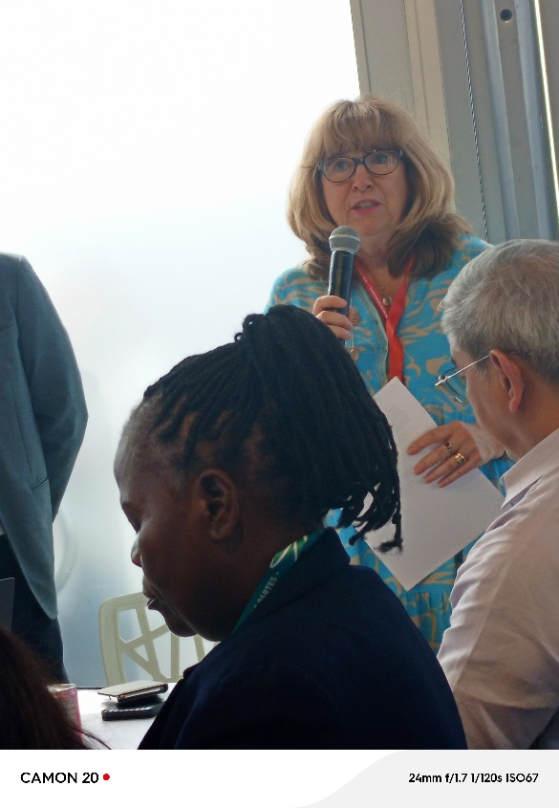

**The Executive Secretary at the side event on CHM stressing the importance of Knowledge Management for effective implementation of GBF**

The side event on National Clearing House Mechanism (CHM) and Bioland 2.0 drew significant participation from party delegates, representatives of national CBD focal points, technical experts, and NGOs focused on biodiversity data sharing and management.

Approximately 50 attendees comprised a diverse group, including government officials from biodiversity and environmental agencies, IT and database experts, as well as representatives from civil society and international organizations involved in capacity-building and biodiversity information management.

Panelists: The panel featured key speakers, including:

Executive Secretary of the CBD: Provided an overview of CHM evolution and its role in supporting national CHMs.

Lead Developer of Bioland Tool: Spoke on technical improvements in Bioland 2.0 and how it facilitates data interoperability and enhances information sharing.

Representatives from countries that have implemented Bioland 2.0 shared their experiences and best practices.

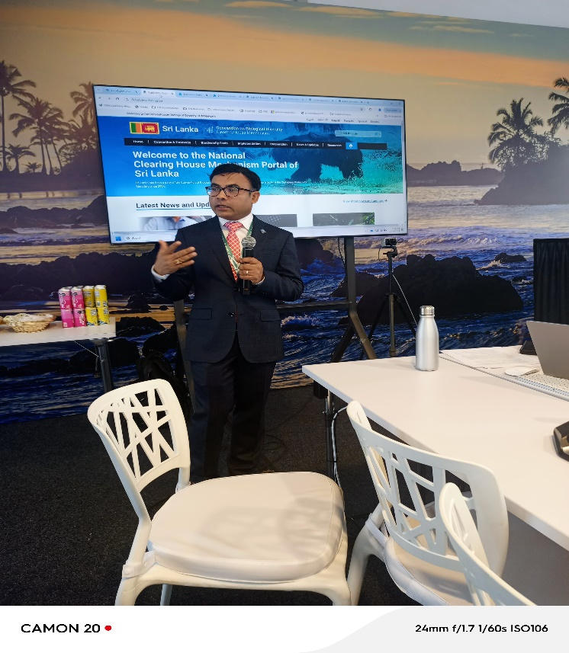

**Panelist from CBD secretariat making a presentation**

**Summary of Key Discussions**

The session highlighted the importance of Bioland 2.0 as an essential tool for enhancing national clearing-house mechanisms, making biodiversity data more accessible and user-friendly. Discussions centered on:

Bioland 2.0's improved functionalities for data management, including streamlined processes for data sharing and access, improved user interfaces, and stronger integration with international biodiversity databases.

For countries lacking an established CHM website, Bioland 2.0 offers a ready-to-use template that populates country profiles with relevant data, which countries can then customize to meet national requirements.

Many delegates emphasized the need for training and technical support to fully utilize Bioland 2.0’s functionalities, especially in developing countries with limited technical capacity.

Panelists discussed strategies for integrating Bioland 2.0 with national monitoring and reporting systems, which could streamline reporting to the CBD and facilitate more efficient national biodiversity data management.

**Outcomes Relevant to Kenya’s Interests**

Establishing Kenya’s CHM on Bioland 2.0: For Kenya, which is committed to advancing its biodiversity data and reporting capabilities, adopting Bioland 2.0 could enhance its national CHM platform.

Capacity-Building Opportunities: The discussions underscored the availability of resources from UNEP and GEF for capacity-building in countries adopting Bioland 2.0. Kenya could apply for support to train personnel and build technical expertise, ensuring effective use and management of its CHM.

Bioland 2.0’s integration features align with Kenya’s goals under the Global Biodiversity Framework to improve biodiversity monitoring and reporting. Utilizing Bioland could streamline Kenya’s reporting to the CBD, reduce reporting burdens, and promote compliance with international biodiversity commitments.

The central CHM portal improvements support Kenya’s aims to engage in scientific cooperation and share biodiversity knowledge with regional and global partners, potentially boosting technical collaboration and knowledge exchange.

## Access and Benefit-Sharing Clearing-House Training Workshop

**Date and Location**: 27 October 2024, Centro de Eventos Valle del Pacifico, Cali, Colombia, Room: Malpelo (CG 1) - Plaza 1

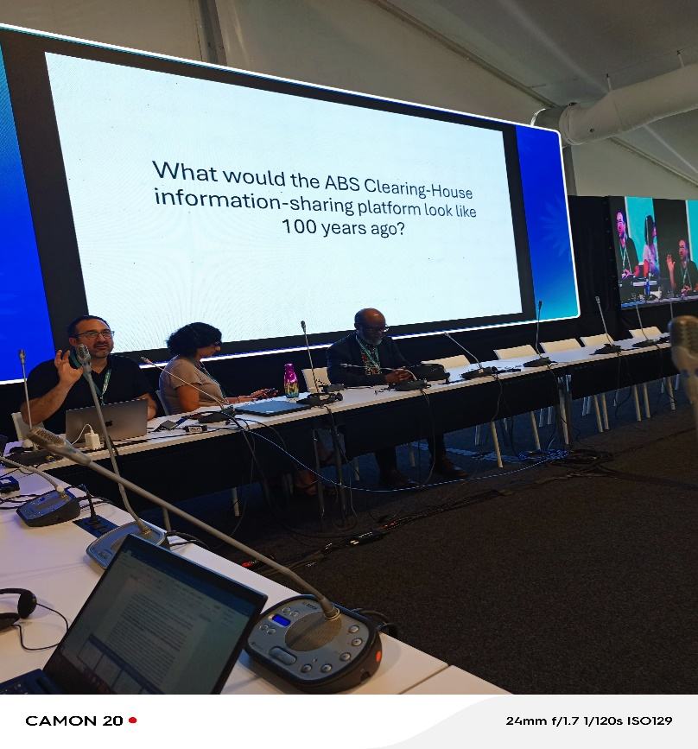

**Panelists at the event**

The workshop was well-attended including government officials, national ABS focal points, legal experts, and representatives from international organizations involved in biodiversity and the Nagoya Protocol.

The audience was primarily made up of ABS focal points from various countries, technical experts, and policy makers who are directly involved in implementing the Nagoya Protocol and its ABS Clearing-House platform.

**Panelists:**

**ABS Clearing-House Coordinator**: Provided an overview of the platform’s functionality, updates, and the strategic vision behind it.

**Legal and Technical Experts**: Discussed key legal and practical aspects of the ABS Clearing-House, highlighting challenges faced by national users and the importance of accurate information.

Several parties shared their experiences and challenges in integrating national ABS information with the global clearing-house platform.

**Representatives from UNEP and CBD Secretariat**: Provided insights into ongoing developments and future plans for enhancing the operations of the ABS Clearing-House.

The workshop focused on:

The ABS Clearing-House has undergone several updates, including enhanced data management tools, streamlined interfaces for easier navigation, and better integration with national ABS frameworks. The workshop emphasized the need for accurate and up-to-date national data to ensure the platform’s effectiveness.

New functionalities are being developed to better support the monitoring of genetic resource utilization and the fair sharing of benefits, making the platform a more robust tool for users.

**Challenges Faced by National Users:**

Many countries, especially developing ones, face significant challenges in fully utilizing the ABS Clearing-House, including technical limitations, capacity issues, and lack of awareness about the platform’s potential.

Discussions highlighted the need for more capacity-building initiatives to ensure that national users can effectively manage and share ABS information on the platform.

**Experiences and Best Practices:**

Participants shared case studies from various countries on how they have overcome challenges related to data accuracy, system integration, and stakeholder engagement in the context of ABS implementation.

Some countries reported progress in aligning national legal frameworks with the Nagoya Protocol, which helped to improve the quality of data submitted to the ABS Clearing-House

The importance of fulfilling information-sharing obligations under the Nagoya Protocol was emphasized. Countries must ensure that the information they provide through the ABS Clearing-House is reliable, accurate, and complete. This is crucial for the protocol’s success in promoting transparency and legal certainty in access to genetic resources.

# Outcomes Relevant to Kenya’s Interests

Kenya can benefit from the ABS Clearing-House by improving the management and exchange of national ABS information. Given Kenya’s significant biodiversity, ensuring that accurate data is uploaded and updated on the ABS Clearing-House would help the country meet its obligations under the Nagoya Protocol.

The workshop highlighted the importance of training and capacity-building for national users. Kenya could seek technical and financial support for training local ABS focal points and other relevant stakeholders in effectively using the ABS Clearing-House. This would also support Kenya’s biodiversity governance and increase its engagement with international ABS initiatives.

By actively engaging with the ABS Clearing-House, Kenya could enhance its role in global ABS discussions and biodiversity conservation efforts. Accurate reporting of ABS data would not only support Kenya's international commitments but also help attract potential benefits from bioprospecting and genetic resource utilization.

The ABS Clearing-House is a critical tool for monitoring the utilization of genetic resources and ensuring that benefits are shared equitably. For Kenya, it is essential to develop strong systems for monitoring the use of its biodiversity and ensuring compliance with the protocols established under the Nagoya framework.

The workshop underscored the value of international cooperation. Kenya could explore opportunities for partnerships with other countries and international organizations to enhance its ABS systems.

Kenya needs to revive its ABS Online permit system developed with support from GIZ

# Kenya Honoured at Global conference -COP16 for Outstanding National Clearing-House Mechanism on Biodiversity

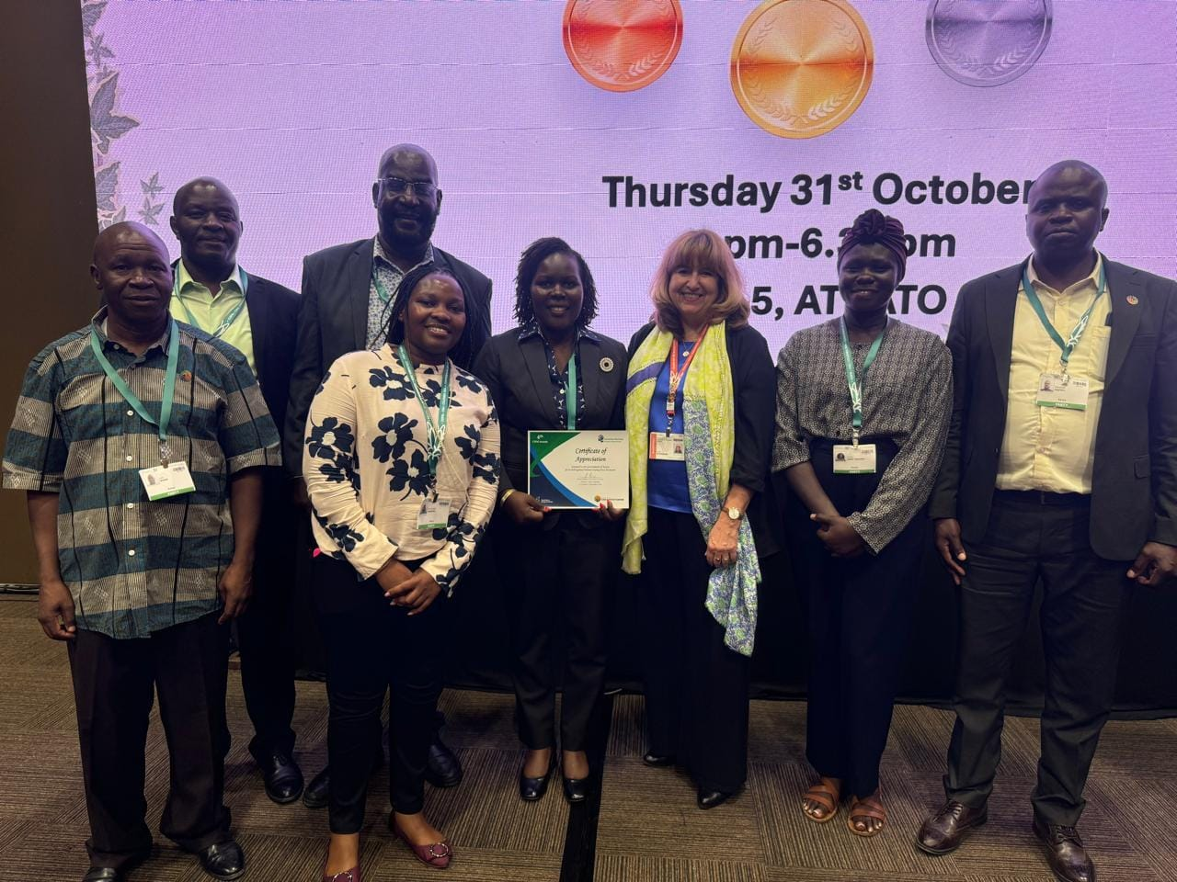

**Delegation from Kenya being awarded**

Kenya was awarded a Certificate of Appreciation on October 31, 2024, during COP16 of the

Convention on Biological Diversity in Cali, Colombia. Presented by CBD Executive Secretary Ms.Astrid Shomaker, the award celebrates Kenyas well-organized National Clearing-House Mechanism (CHM) an online platform for managing and sharing biodiversity data, supporting the implementation Kunming -Montreal Global Biodiversity Framework .This recognition highlights Kenya’s leadership in biodiversity knowledge management and conservation, underscoring its commitment to the implementation of Global Biodiversity Framework.

Since earning the Bronze Award for its New National CHM in 2016 at COP13 in Mexico, Kenya has significantly advanced its CHM capabilities. Integrated with the nation’s Biodiversity Strategy and Action Plan, Kenya’s CHM focuses on strengthening biodiversity information collection, monitoring, and accessibility. The CHM current platform, Bioland 1.0, offers extensive data on biodiversity, and Kenya looks forward to upgrading to Bioland 2.0 to improve interoperability and user experience. Kenya also supports UNEP’s global project proposal to strengthen CHMs across nations, seeing it as vital to bridging gaps in technical and scientific capacity ensuring that data sharing and knowledge management truly become pillars of our shared global biodiversity objectives.

In Kenya, the National Environment Management Authority (NEMA) serves as the National Focal Point for the Clearing-House Mechanism (CHM). NEMA is responsible for maintaining the platform, updating essential biodiversity data, and promoting national awareness, ensuring the CHM remains a robust resource for conservation and informed policy decisions.

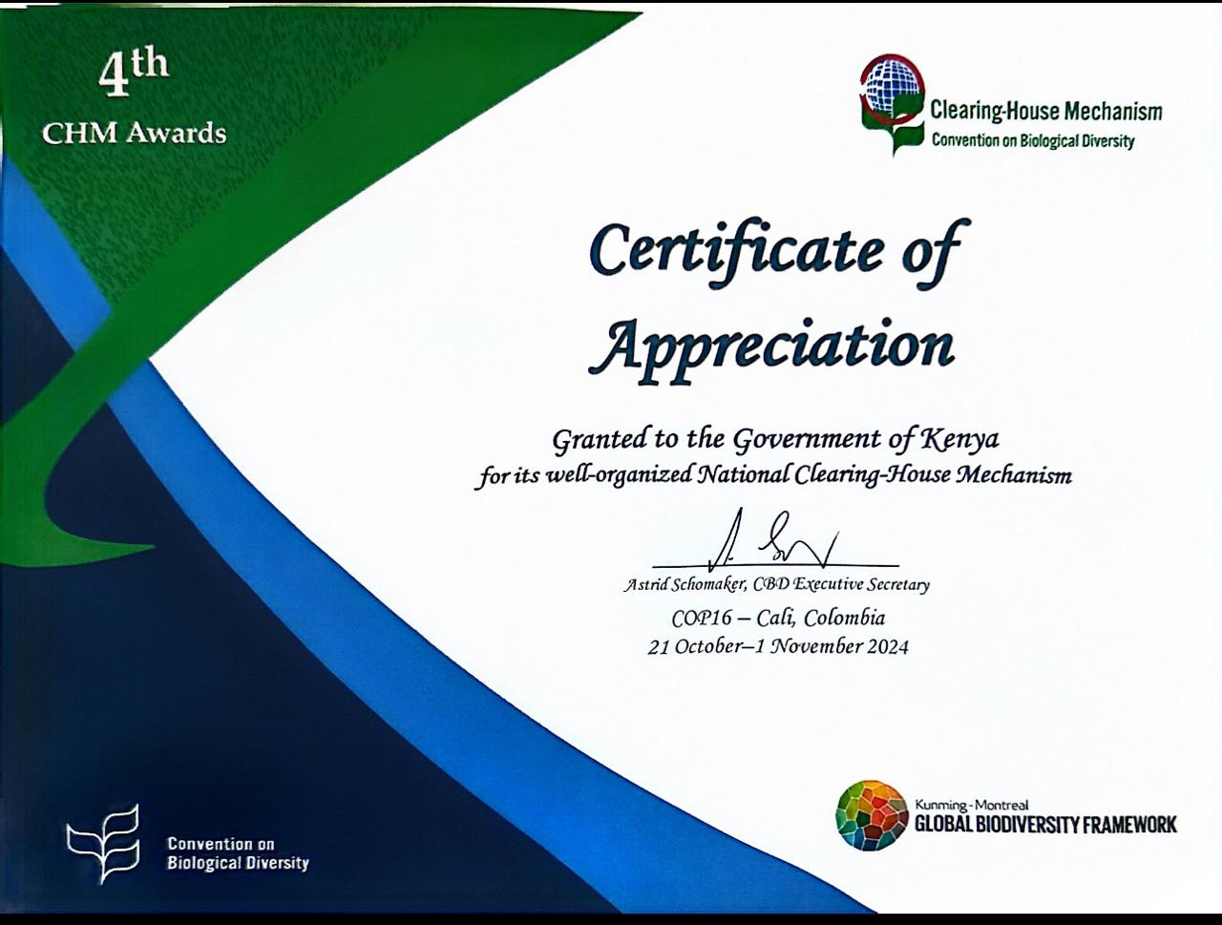

**Conclusion and challenges faced in my participation**

**Conclusion**

Participation in COP16 was a valuable opportunity to engage with global stakeholders, exchange knowledge, and contribute to critical discussions on biodiversity conservation and sustainable use. The sessions and side events I attended enhanced my understanding of mechanisms for planning, monitoring, and reporting under the Kunming-Montreal Global Biodiversity Framework (GBF). Additionally, the capacity-building workshops on the Clearing-House Mechanism (CHM) and Access and Benefit-Sharing (ABS) mechanisms provided practical insights that will significantly inform Kenya's efforts in implementing its national biodiversity targets.

The side events, such as the National CHM and Bioland 2.0 presentation, showcased innovative tools and approaches that Kenya can leverage to enhance its CHM functions. These experiences reinforced the importance of collaboration and the role of digital platforms in advancing knowledge management and transparency.

Overall, my participation underscored the critical importance of mainstreaming biodiversity across sectors and valuing biodiversity's diverse contributions, aligning with Kenya’s efforts to achieve its biodiversity and sustainable development goals.

**Challenges Faced**

1. **Time Constraints:** The packed schedule of sessions and side events made it challenging to attend all discussions relevant to Kenya’s biodiversity priorities. Some overlapping sessions required careful prioritization, resulting in missed opportunities to participate in potentially beneficial discussions.
2. **Technical Complexity:** Certain sessions, particularly on Bioland 2.0 and ABS Clearing-House, required advanced technical knowledge, which necessitates further follow-up and capacity building to fully utilize these tools in Kenya’s context.
3. **Networking Barriers:** Engaging with a diverse range of stakeholders was sometimes hindered by time limitations, reducing opportunities for in-depth discussions and collaboration-building.
4. **Limited Resources for Follow-Up by NEMA:** Translating the lessons learned and tools introduced during COP16 into actionable outcomes at the national level may face resource and capacity challenges that require additional support and stakeholder engagement.
5. **Inadequate Financial Support**: While the support provided by the Royal Belgian Institute of Natural Sciences (RBINS) was greatly appreciated, the daily subsistence allowance (DSA) was relatively low, making it difficult to meet essential needs during the conference. This highlighted the need for additional support from NEMA to ensure its representatives can participate effectively and comfortably in such critical international engagements. Enhanced financial backing would not only facilitate smoother participation but also reinforce Kenya’s presence and contributions on the global stage.